**Static initialization blocks**

**They** a special feature of a class that enable more flexible initialization of static properties than can be achieved using per-field initialization.

A class can have any number of static {} initialization blocks in its class body. These are evaluated, along with any interleaved static field initializers, in the order they are declared. Any static initialization of a super class is performed first, before that of its sub classes.

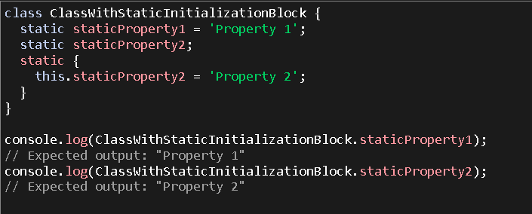

**Using this and super**

The this inside a static block refers to the constructor object of the class. This code shows how to access a public static field.

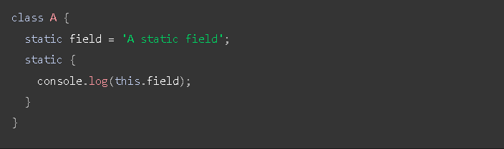

The super.property can be used inside a static block to reference properties ofsuper class. This includes static properties, as shown below:

